**GCS TO BIGQUERY BY Auto Table Creation**

* Create a cloud function triggered by a GCS bucket event.  
  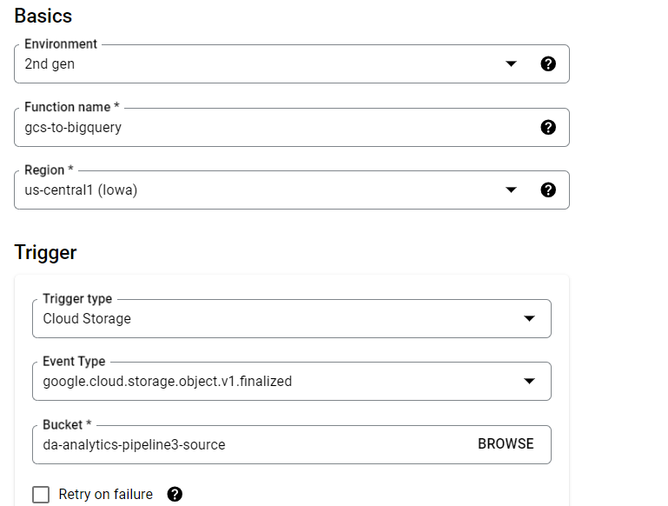  
  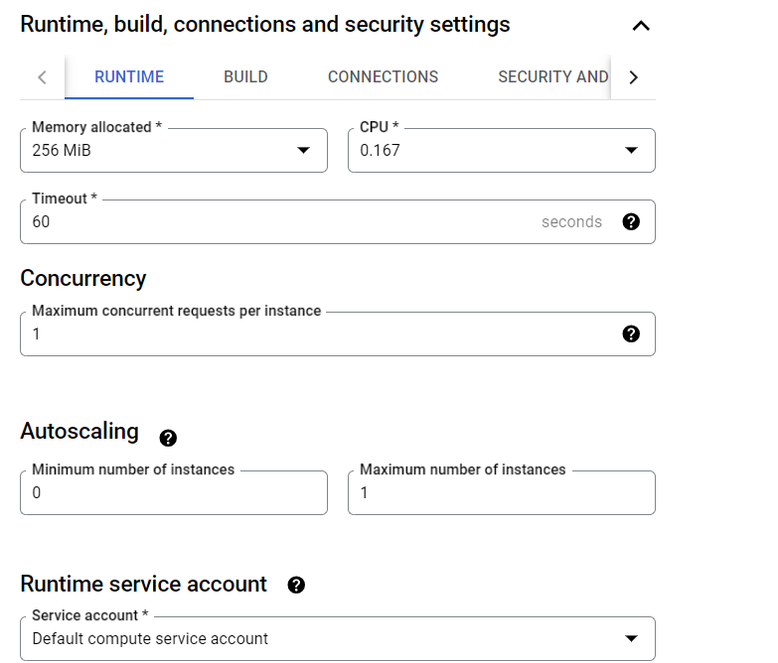
* Write down the code to copy data from GCS file to BigQuery by automatically detecting the schema and creating the table in big query.  
  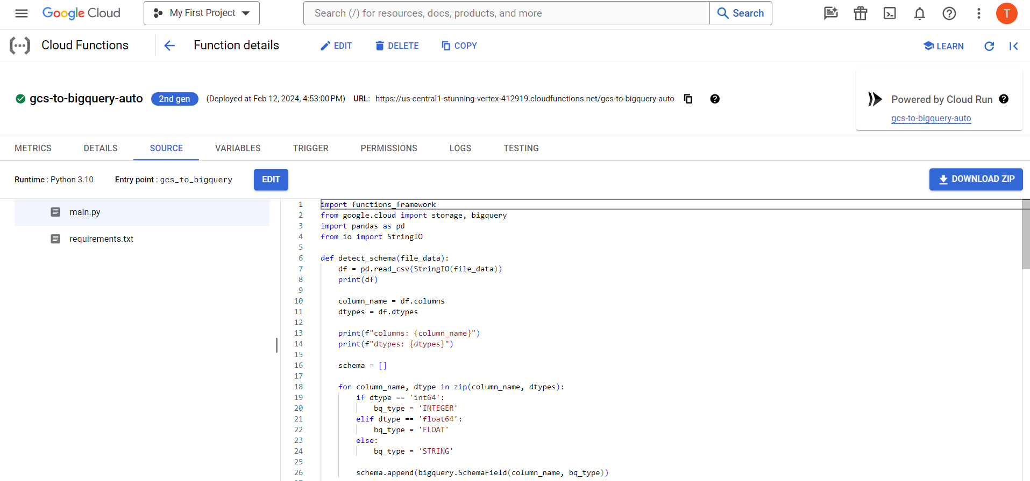  
  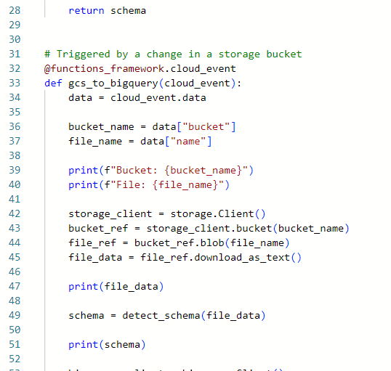  
  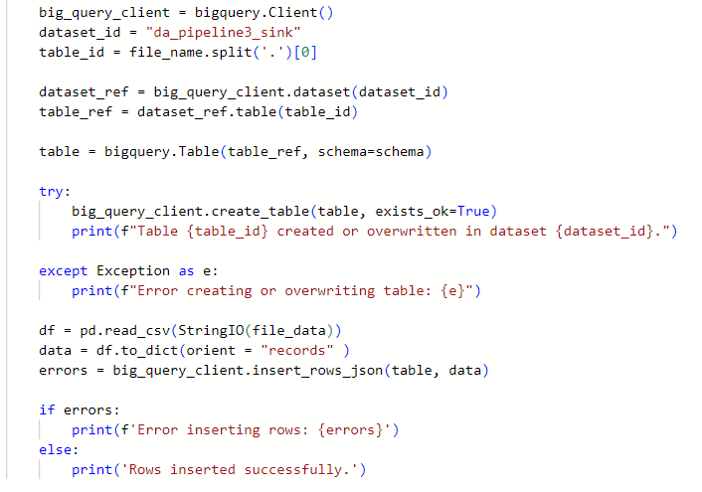
* Now Deploy this function and then upload the file in GCS.
* You will see that the table got created and the data got successfully inserted in Big Query table.  
    
  